GENERAL BACKGROUND

1. PROGRAM INTRODUCTION

New York State is blessed with more than 7000 lakes, ponds, and reservoirs. Many of these waters are used by the public for recreation. As more people use these lakes and their surrounding watersheds, the potential for pollution problems and use impairment increases dramatically. Many of these lakes have a tremendous capacity to accommodate, in the short term, the stress imposed by man's activities, but will ultimately suffer under such a burden. Thus, there is a paramount need for lake management plans to help minimize the adverse impacts.
However, the tremendous number and diversity of water bodies, and the problems associated with these waters, makes statewide management a difficult task. A single, statewide management plan cannot possibly account for the characteristics and nuances unique to each lake. Ideally, management decisions are based on an evaluation of available information, including historical and current chemical, physical, and biological data, levels of use, and use impairment. Unfortunately, reliable information is either sparse or non-existent for many waterbodies in New York State, and neither the funding nor the manpower presently exists for the New York State Department of Environmental Conservation to collect this information for more than a small subset of these waters each year.
The New York Citizens Statewide Lake Assessment Program (CSLAP) is a cooperative effort between the New York State Department of Environmental Conservation (NYSDEC) and the New York Federation of Lake Associations, Inc. (FOLA). The specific goal of the Program is to implement a scientific and educational program in which lay volunteers are trained to collect information and samples on ponded waters. This information is used to develop management strategies specifically tailored to each Program water. The Program considers several objectives that are fundamental to the development of successful management strategies for ponded waters in New York State. These include:

(1) the collection of reliable data on individual waters to provide baseline information and document trends in water quality;

(2) the identification and assessment of specific problems on individual waters and recommendations to deal with these problems; and

(3) the education of lake residents, users, and interested citizens in the collection of water quality data, lake ecology, and management practices

The NYSDEC and FOLA are committed to protecting the quality of all New York state waters. Many concerned citizens share in this commitment. Through the CSLAP, it is hoped that all participants will attain a better understanding of the importance of these valuable resources, and extend this knowledge above and beyond this program to pursue ecologically sound management practices.

2. PROGRAM BACKGROUND AND SUMMARY

The Citizens Statewide Lake Assessment Program was initiated in 1985, with the support of New York Governor Mario M. Cuomo, and was modeled after successful volunteer programs in Vermont, Maine, Illinois, and Minnesota.
Each participating association is a member of FOLA, a not-for-profit coalition of lake associations that acts as an information clearinghouse for all aspects of environmental management of New York lakes. FOLA was founded in 1983, and presently supports a membership of more than 700 individuals, corporations, and lake associations.
Citizen volunteers from FOLA-member associations are responsible for collecting biweekly water quality data and samples from June through October. To facilitate this process, the NYSDEC and FOLA have written this manual describing sampling protocol. The manual will provide simple, easy-to-follow instructions for on-site sampling techniques and water sample processing.
Water samples are sent to a state certified laboratory for chemical analyses. These results and other lake measurements are forwarded to the NYSDEC and FOLA and stored on computer file. The results of the sampling will give an indication of current conditions, and a comparison to historical data gives an estimate of water quality changes and trends. This allows for a prediction of future water quality conditions, and will provide the NYSDEC and lake associations with a basis for making management decisions for each water body.
To obtain the data necessary to provide an accurate assessment of the water quality for a particular body of water, and to allow a comparison of data over time, it is imperative that water samples be collected accurately and consistently. This involves a complete commitment from volunteers and a strict adherence to outlined standard procedures.

3. SAMPLING PARAMETERS

Within all lake ecosystems exist dynamic interactions between organisms and their environment. The health and well-being of a lake depend on the nature of these interactions. Since these interactions are both numerous and complex, it is impossible to completely assess the water quality of a lake. However, by looking at some chemical, physical, and biological properties of the lake, it is possible to gain a greater understanding of the general condition of lakes.
A number of parameters, such as nitrogen, phosphorus, calcium, pH, and specific conductance, can lend much insight to the chemical makeup of a lake. Lakes can also be characterized by physical parameters, such as temperature, water color, and water clarity, or by biological parameters such as chlorophyll a (a measure of algae densities). Each of these parameters are regularly analyzed in CSLAP, and are described in more detail below.

PARAMETERS ANALYZED FOR THE
CITIZENS STATEWIDE LAKE ASSESSMENT PROGRAM

PARAMETER SIGNIFICANCE

Water Temperature Water temperature affects many lake activities, including the rate of
(°C) biological growth and the amount of dissolved oxygen. It also influences the
length of the recreational season

Transparency Determined by measuring the depth at which a black and white disk
(meters) disappears from sight, the Secchi disk transparency estimates the clarity of
the water. In lakes with low color and rooted macrophyte ("weed") levels, it is
related to the productivity of the lake

Conductivity Specific conductance measures the electrical current that passes through
(µmho/cm) through water, and is used to estimate the number of ions (charged
particles). It is somewhat related to the hardness of the water, and may
influence the degree to which nutrients remain in the water column

pH pH is a measure of the (free) hydrogen ion concentration in solution. Most
clearwater lakes must maintain a pH between 6 and 9 to support most types
of plant and animal life. Low pH waters (<7) are acidic, while high pH
waters (>7) are basic

Color (true) The color of dissolved materials in water usually consists of organic matter,
(platinum color units) such as decaying macrophytes or other vegetation. It is usually not necessarily
indicative of water quality, but may significantly influence water transparency
or phytoplankton (algae) growth

Phosphorus Phosphorus is one of the major nutrients needed for plant growth. It is often
(total, mg/l) considered the "limiting" nutrient in NYS lakes, for biological productivity is
often limited if phosphorus inputs are limited. Many lake management plans
are centered around phosphorus controls

Nitrogen Nitrogen is another nutrient necessary for plant growth, and can act as a
(ammonia limiting nutrient in some lakes, particularly in the spring and early summer. In
and nitrate, mg/l) high concentrations, ammonia and nitrate can result in ecological impairment. Total
nitrogen is comprised of ammonia, nitrate (+ nitrite) and organic nitrogen

Chlorophyll a The measurement of chlorophyll a, the primary photosynthetic pigment
(µg/l) found in green plants, provides an estimate of phytoplankton productivity,
which may be strongly influenced by phosphorus

Calcium Calcium is usually a major component of lake buffering capacity (the ability of lake
(mg/l) water to neutralize acidic inputs) and is required for zebra mussels to build their shells

Use Impairment Surveys Evaluated through the use of field perception forms (four question surveys completed
during each sampling session), use impairment surveys link recreational lake use
assessments to water quality data

SAMPLE PROCEDURES

1. SAMPLING VOLUNTEERS

Although the following sampling procedures have been devised to reduce inconsistencies in sampling techniques, inevitably there will be subtle differences in techniques from volunteer to volunteer. This is apparent in the more "interpretive" tests such as Secchi disk readings and observations of field weather conditions. To minimize the potential for large errors, the sampling procedure should be performed by the same person(s) during each sampling session.
This program calls for two primary and at least two secondary volunteers. The primary volunteers are expected to perform the sampling procedures every other week, while the secondary volunteers are "on-call" to substitute for the primary volunteers. If a primary volunteer can anticipate missing any given sampling date, (s)he should meet with the secondary volunteer prior to this date (ideally, on site during the previous sampling session). At this time, the primary volunteer should pass along the sampling equipment and any pertinent information concerning sampling techniques. This allows for consistent measurements throughout the sampling season. While the actual sampling should be performed by the primary team every other week, other volunteers are encouraged to observe CSLAP testing procedures.
Finally, a volunteer should never go out on the lake alone. There should be at least two volunteer monitors, with the appropriate boating safety gear, present at all times.

2. SAMPLING DAYS AND TIMES

It is important to be consistent in the choice of sampling days. The sampling day should be the most convenient for all potential sampling parties, especially the primary monitors. Samples must be stored, shipped, and received in the laboratory at a cool temperature. The NYSDEC and FOLA ask that sampling be performed between Saturday and Tuesday. The samples must be refrigerated overnight, and mailed the next available mailing day (Monday, Tuesday, or Wednesday). Samples mailed later in the week may result in a loss of refrigeration while samples are held in transit. Due to weather conditions or outstanding personal conflicts, it is not always possible to sample on the same day. In these instances, samples should be taken sometime within this four day span. If samples can only be collected between Wednesday and Friday, they must be refrigerated until the following Monday.
The ideal time to sample is on bright, calm days between 8:00 AM and noon (this should be kept in mind when choosing the regular sampling day). Since water quality characteristics fluctuate with the time of the day, it is important to have a regular sampling time. This time should always be recorded, especially if it is not possible to maintain a consistent sampling time.

3. SAMPLING FREQUENCY

When CSLAP was originally developed and implemented in 1985, participating volunteers collected water samples every week from June through September. However, since then the number of interested lake associations has exceeded the financial capacity of the program. One cost-savings modification employed to allow more lakes into the program was to reduce the sampling frequency from weekly to biweekly. While for some lakes, weekly samples provided a means to document most of the variability in water quality experienced over the course of the sampling season, for the majority of the CSLAP lakes, it was determined that biweekly samples adequately identified most of the important water quality changes. As such, the decision to reduce the sampling schedule was reached with only a minimal disturbance to the efficacy of the program. For lake associations developing their own monitoring program, sampling frequency should be defined by the data objectives and the characterization of the sampled lake. In this program, however, all lakes are sampled biweekly.

4. SAMPLING LOCATION

On most CSLAP lakes, only one location will be monitored, since general water quality characteristics of many lakes can be determined by sampling within the deepest portion of the lake. It is important that the sample consistently be taken from the same location during each sampling session. Instructions in this manual should insure that the sample depth and location are consistent from week to week.
The sampling site corresponds to the deepest portion of the lake. This can be located by using a bathymetric map, or through measurements by local fishermen or lake users. Once the deepest point is located, it is helpful to locate permanent landmarks along the shore which can easily mark the site for future sampling trips (if a permanent buoy or marker is not available). Sampling from the deepest portion of the lake is also important because bottom samples will be collected from each thermally stratified (warm layer on the top, cold layer on the bottom in the summer) CSLAP lake. If sampling is not conducted at the deepest portion of the lake, the sampling results from these deepwater samples will provide only limited information about the lake.
From this location, a distant landmark (the blue house, a tall oak tree, etc.) should be located. Assume this location to represent 12 o'clock. Then, from a sitting position, the volunteer should look 90° to the left (at 9 o'clock), and find a second landmark. Turning twice more 90° to the left, the volunteer should find third and fourth landmarks at 6 o'clock and 3 o'clock, respectively. Thus, the sample location should be marked by four landmarks. The imaginary lines connecting these landmarks will cross at the site location. The volunteer can find the site at any time by locating the four landmarks, and find where the lines cross. This will work only if the landmarks are permanent fixtures.

- INVASIVE AQUATIC PLANTS

The primary focus of this CSLAP Sampling Protocol is to familiarize sampling volunteers with the procedures necessary to properly collect, process, and transport samples collected through this program. However, the process by which volunteers travel to sampling sites provides an additional opportunity to conduct surveillance for invasive aquatic plants, primary submergent exotic plants, that can create the most significant ecological or use-based problems facing many lakes, particularly since an early detection and proper identification of these plants can greatly improve the chances of controlling or even eradicating these invasive plants. The Aquatic Vegetation Sampling portion of the CSLAP sampling protocol (at the end of this document) provides information about these invasive plants, and any CSLAP volunteer interested in or concerned about invasive plants is encouraged to consult this portion of the sampling protocol. Even those volunteers not formally conducting Aquatic Vegetation surveys with this protocol are encouraged to collect and submit any plants that resemble these invasive plants, for identification by professional staff at the NYSDEC. Line drawings and brief descriptions of these plants are provided in Appendix A.

WATER SAMPLING EQUIPMENT CHECKLIST
Equipment to be brought into the boat

______ anchor and line (at least 2x as much line as depth of lake)
______ lake map
______ watch to record the time of day
______ pen or pencil
______ CSLAP Sampling Protocol
______ "Sampling Record" form
______ “Field Observations” form
______ field equipment crate:
______ thermometer
______ Secchi disk and measured line
______ Kemmerer sampling bottle and measured line
______ collapsible water sample container and cap with spigot
______ hypolimnetic sampling container (optional- only for those
stratified lakes collecting hypolimnetic samples)
______ one safety jacket per boat passenger (required by US Coast Guard)
______ first aid kit (optional but recommended)

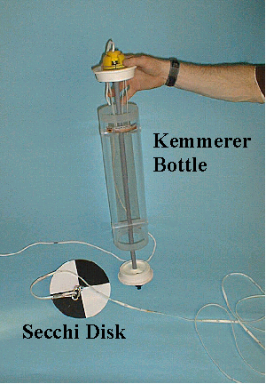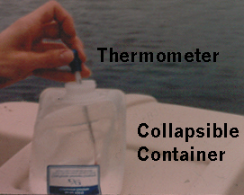
LABORATORY EQUIPMENT CHECKLIST
Equipment to be left on shore

______ laboratory equipment crate
______ package of vinyl gloves
______ wash bottle with distilled water
______ filtration apparatus
______ funnel (large top piece)
______ centerpiece with removable plate
______ receiving flask with port holes
______ rubber hose
______ rubber stoppers
______ hand vacuum pump
______ forceps (tweezers)
______ jar of filters
______ small graduated cylinder
______ large (125 mL) sample bottles
______ MgCO3 dispensing bottle
______ chlorophyll a vial (replaces small glass tube used prior to 2003)
______ CSLAP Sampling Protocol
______ "Sampling Record" and “Field Observations” forms
______ “Chain of Custody” and “Request for Analysis” form

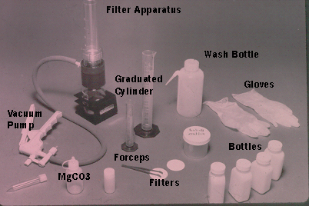

Shipping Materials

______ styrofoam shipping boxes with lids and cardboard mailers
______ pre-paid shipping labels (UPS or USPS)
______ frozen ice packs (2 per shipping box)
______ return address labels (UPS only)
______ aluminum foil (supplied by lake association)
______ packing tape (supplied by lake association)

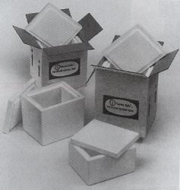
ON-LAKE PROCEDURES

The following section outlines the step-by-step procedures that the volunteers should follow during each sampling trip. Once the volunteer is familiar with these procedures, (s)he can refer to the condensed sampling procedures list in the back of the book.
To maintain sample reliability, it is important for volunteers to precisely follow each of the outlined steps.

Step 1: Load all equipment into the boat
a. Check the sampling equipment list to make sure all necessary equipment is on board
b. To avoid upsetting the boat, place the sampling equipment in a suitable place close to the appropriate sampling volunteer

Step 2: Locate the sampling site
a. Once close to the sampling site, locate the four shoreline landmarks
b. Create two imaginary lines connecting these permanent landmarks. The point where these lines cross should be the correct sampling site

Step 3: Check the depth and anchor the boat
a. With Secchi disk in hand, proceed to the shaded side of the boat, with an equal number of volunteers on the other side of the boat for balance
b. While in a sitting or kneeling position, lean over the side of the boat, and lower the Secchi disk into the water until it rests on the lake bottom
c. Read the depth from the Secchi disk line. If this is within 10% of the maximum depth (from the bathymetric map or other data source), then secure the position of the boat with the anchor
For example, in a lake with a maximum depth of 15.0 meters, an acceptable estimate of maximum depth would be within 10% of 15 meters, or 1.5 meters. Thus, any depth measurement between 13.5 meters and 16.5 meters would be acceptable for your sampling site
d. Record the depth from the Secchi disk line to the nearest ¼ meter (if the line is marked every meter; read to the nearest 0.1 meter or foot if a measured tape serves as the Secchi disk line) on the Sampling Record form as the "SOUNDING DEPTH" (#1 on the Sampling Record form on Figure 3)
e. If this depth is not within 10% of the maximum depth, then raise the Secchi disk a few meters off the bottom, check the landmarks again, as designated in Step 2, reposition the boat if necessary, and return to Step 3b
f. Once the site has been identified, raise the Secchi disk out of the water, and remove any bottom mud or sediment that may have been deposited on the disk
g. If the boat drifts from the correct site, pull up the anchor, and return to Step 2. If the drifting continues (due to strong winds) then try sampling on another day, if possible. If not, attempt to maintain the boat position above the deepest section throughout the sampling session
Figure 3
CSLAP Sampling Record
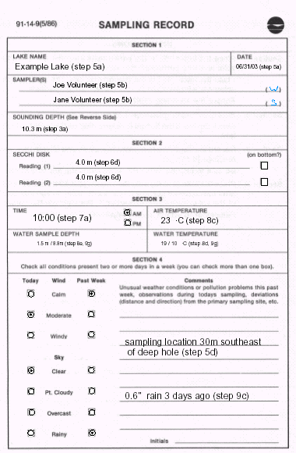

Step 4: Complete CSLAP Field Observations Form
a. Complete information on top of form (Lake Name, Date, and Time as #1, #2, and #3, respectively) on Figure 4
b. Provide one answer only to the first question (A) on the Field Observations Form. This question asks the primary volunteer to assess the physical condition of the lake on the whole, not in just one part of the lake, during this sampling session. If conditions are significantly different from one site to another, then consider the response to question A to be the “average” for the entire lake. This question refers only to the influence of algae or turbid water (not weeds or debris) on the lake clarity
c. Provide one answer only to the second question (B). This question asks the primary volunteer to assess the aquatic plant (weeds) populations at the time of the sampling in the nearshore areas of high usage, such as the areas surrounding docks, beaches, and common access points. This should not include those shallow areas that do not serve as common usage areas, such as wetlands in an undeveloped part of the lake. If possible, the same nearshore areas should be evaluated during each sampling session, to allow an approximate comparison of assessments between sessions.
d. Provide one answer only to the third question (C). Like the first question, the third question also involves a lake-wide assessment, related to the recreational suitability of the lake. This should also be considered an average evaluation for the lake at the time of sampling.

FIGURE 4

Lake Name_________________ Date _____________
CSLAP FIELD OBSERVATIONS FORM

(A) PLEASE CIRCLE THE ONE NUMBER THAT BEST DESCRIBES THE PHYSICAL CONDITION OF THE LAKE WATER TODAY:
1. Crystal clear water
2. Not quite crystal clear- a little algae visible
3. Definite algae greenness, yellowness, or browness apparent
4. High algae levels with limited clarity and/or mild odor apparent
5. Severely high algae levels with one or more of the following: massive floating scums or streaks on lake or washed up on shore, strong foul odor, fish kills

(B) PLEASE CIRCLE THE ONE NUMBER THAT BEST DESCRIBES THE AQUATIC PLANT POPULATIONS IN AREAS WHERE PEOPLE SWIM AND BOAT TODAY:
1. No plants visible from the lake surface
2. Some plants are visible underwater, but do not grow to the lake surface
3. Some plants grow to the lake surface
4. There is dense plant growth at the lake surface
5. Dense plant growth completely covers the lake surface except in the deepest areas

(C) PLEASE CIRCLE THE ONE NUMBER THAT BEST DESCRIBES YOUR OPINION OF THE SUITABILITY OF THE LAKE FOR RECREATIONAL ENJOYMENT TODAY:
1. Beautiful, could not be nicer
2. Very minor aesthetic problems- excellent for swimming, boating, and overall use
3. Swimming and aesthetic enjoyment slightly impaired
4. Desire to swim and enjoy the lake substantially reduced, although the lake can be used
5. Swimming and aesthetic enjoyment of the lake impossible

(D) PLEASE CIRCLE ALL NUMBERS THAT AFFECT YOUR OPINION OF RECREATIONAL USE OF THE LAKE TODAY:
- Poor water clarity and/or water color, including turbid water
- Excessive weed growth (circle all that apply: emergent plants, floating plants, submergent plants)
- Too much algae and/or odor
- The lake looks bad
- Poor weather (windy, overcast, water too cold, etc.)
- Litter, surface debris, other beached or floating material, including foam and pollen
- Too many lake users (circle all that apply: boaters, swimmers, jet skiiers, other)
- Other ______________________________________________________________

The recreational suitability can be influenced by algae or water clarity, rooted plants, aesthetics, weather conditions, lake usage (too many or too few people or boats), or other conditions. In other words, non-water quality factors can also be considered.
e. Provide as many answers as appropriate to the fourth question (D), which asks the primary volunteer to indicate which factors affected his/her answer to Question C. While some responses to Question D will probably match closely to responses in Questions A and B, Question D should be answered independently of these other questions.
f. These questions should be answered before Step 6.

Step 5: Complete Sampling Record form: Section 1
Complete the top part of the sampling record form:
a. Record lake name and date of sampling on section 1 of the Sampling Record
b. Record the names of all volunteers participating in the current sampling session on the Sampling Record (section 1)
c. In parentheses, place an (s) after the name of the volunteer using the Secchi disk, and a (w) after the name of the volunteer who will collect the water chemistry sample on the Sampling Record
d. If the present location is different than the location determined in Step 2 (due to drifting, for example), then try to estimate the distance (in meters; conversions in the back of the manual) and the direction needed to travel (northeast, south, etc.) to reach the location determined in Step 2. Mark this under "Comments" in Section 4 of the Sampling Record form

Step 6: Measure Secchi disk transparency
a. Lower the Secchi disk into the water on the shaded side of the boat until it just disappears from sight. The disk may be difficult to see if there is wave action or glare; however, with patience, the Secchi disk can be seen
b. Read the depth from where the Secchi disk line touches the water surface, and record this depth (to the nearest ¼ meter for marked lines, to the nearest 0.1 meter or foot on measured tape lines) under Section 2 on the Sampling Record form as "SECCHI DISK Reading (1)". Be certain to include the units used in the measurement (if the line is marked in meters, write “meters” or “m” after the reading; if the line is marked in feet, write “feet” or “f” after the reading). If the line does not start at “0” (some of the Secchi disk lines are measured starting at 10 meters, 15 meters, or 20 meters), make sure to record this information on the Sampling Record.
c. If the disk is still visible as it rests on the lake bottom, check the box marked "on bottom?" next to "SECCHI DISK Reading (1)"
d. Lower the disk an additional meter (if possible), and raise the disk until it first reappears in sight. Record this depth as "SECCHI DISK Reading (2)”
e. Raise the disk out of the water, and secure in an appropriate storage place

Step 7: Collect the water sample
a. Record the time of the day, and check the appropriate box, under "TIME" in Section 3 of the Sampling Record form
b. Remove the cap and spigot of the collapsible container, and place the container over the side of the boat
c. Fill the container about ¼ full with lake water, cap the collapsible container, and swish the contents of the container
d. Uncap the container, empty the contents into the lake, and place the container aside. This is called "acclimating" the sample container
e. Hold the Kemmerer bottle stopper in the right hand, and the top stopper in the left hand
f. While holding the top stopper, give a short, hard pull to the bottom stopper. The click should indicate the Kemmerer bottle is cocked into an open position
g. Lower the Kemmerer bottle into the water to the required depth. Unless otherwise indicated, this is the depth where the red mark on the Kemmerer bottle line is flush with the water surface (= 1.5 meters). If you are collecting a sample from a greater depth, such as for hypolimnetic sampling, the Kemmerer bottle should be lowered to the pre-determined depth marked by single or double black lines on the Kemmerer bottle line. Please see the instructions for deepwater sampling under ADDITIONAL SAMPLING PROTOCOLS: 2. HYPOLIMNETIC SAMPLING later in this document.
h. Release the messenger, and give a short tug to the line as the messenger first touches the Kemmerer bottle. This will enclose the top and bottom stoppers and entrap the water sample
i. Slowly bring the Kemmerer bottle out of the water and into the boat
j. Grab the Kemmerer bottle by the center gray shaft to prevent premature opening of the bottle.

Step 8: Transfer the water sample to the collapsible container
a. Place the bottom valve nozzle of the Kemmerer bottle over the opening in the collapsible container
b. Compress the valve spring by pushing up on barrel surrounding the nozzle. Keep the spring compressed and valve opened until the collapsible container is filled
c. Remove the cap on the thermometer, and record the air temperature (to the nearest 1°C) under "AIR TEMPERATURE" on Section 3 of the Sampling Record form. Make sure the thermometer reading has stabilized before reading
d. Immerse the thermometer in the collapsible container. When the thermometer reading stabilizes (usually within a few minutes), record this temperature to the nearest 1°C under "WATER TEMPERATURE" on Section 3 of the Sampling Record form.
e. Record the water sample depth as 1.5 meters under "WATER SAMPLE DEPTH" in Section 3 of the Sampling Record form. Other sample depths (as requested for special studies) should be recorded to the nearest 0.1 meter as estimated from the Kemmerer bottle line

Step 9: Collect the Deepwater Sample
For CSLAP lakes that are thermally stratified (form distinct upper and lower layers, based on water temperature), sample bottles are provided for collecting and processing deepwater samples. For most CSLAP lakes, it is assumed that lakes with a maximum (sounding) depth of greater than 8 meters (26 feet) are thermally stratified. If a second set of bottles (labeled “Deepwater Samples”) and a second collapsible container marked “Deepwater Sample” have been provided in the kit of sample bottles, then the following procedures apply to your lake. Unless otherwise instructed, all deepwater samples will be collected from a depth of appx. 1.5 meters from the bottom of the lake, as defined by the Sounding Depth measurement reported in Section 1 of the Sampling Record (step 3c above).
a. Steps 9a and 9b are the same procedures used in the CSLAP SAMPLING PROTOCOL: ON-LAKE PROCEDURES Step 7 above. Hold the Kemmerer bottle stopper in the right hand, and the top stopper in the left hand. While holding the top stopper, give a short, hard pull to the bottom stopper. The click should indicate the Kemmerer bottle is cocked into an open position.
b. Lower the Kemmerer bottle to a depth of 1.5 meters from the sounding depth- consult the Sampling Record if this depth is not easily recalled. The Kemmerer line should be divided into 1 meter intervals with a black marker, and 5 meter intervals are marked with combinations of black and red markings.
c. Release the messenger, and give a short tug to the line as the messenger first touches the Kemmerer bottle. This will enclose the top and bottom stoppers and entrap the water sample. Wait for several seconds, until bubbles appear at the surface, somewhere near the boat. This should indicate that the sample has been trapped.
d. Slowly bring the Kemmerer bottle out of the water and into the boat
e Grab the Kemmerer bottle by the center gray shaft to prevent premature opening of the bottle
f. If the Kemmerer bottle did not close, return to Step 4b
g. Repeat Steps 8a through 8e to transfer water into the collapsible container marked “Deepwater Sample” and to measure and record water temperature. If the second collapsible container is not distinguished from the first collapsible container (with a “Deepwater Sample” or other label or marking), make sure it is marked distinctly prior to transferring water into the bottle.

Step 10: Complete Sampling Record: Section 4
a. Check the appropriate box for present "WIND" and "SKY" conditions under the columns headed with "TODAY" in Section 4 of the Sampling Record form. To assess general wind conditions, the following rules may be helpful: if the boat does not move even without the anchor, it is "calm"; if it moves somewhat even with the anchor, it is "windy", and if it moves only when not anchored, it is "moderate". For sky conditions: "clear" means no or very few clouds, "pt.cloudy" means cloudy cover but mostly sunny, "overcast" means cloudy with no sunshine, and "rainy" means ... well, rain.
b. Check the appropriate boxes for "WIND" and "SKY" conditions in the past week under the columns headed with "PAST WEEK" in Section 4 of the Sampling Record form. Any conditions that were present for two or more days in the previous week should be marked; more than one box can be checked
c. In the area marked "Comments", record any unusual events or conditions which occurred within the past week which may impact the water quality of the lake. This may include, but is not limited to, algal blooms, fish kills, excessive weeds or turbidity, chemical applications, or excessive activity. This space may also be used to record any unusual weather conditions, including amounts and dates of rainfall, extreme temperatures or winds, or high humidity

Step 11: Wind the Secchi disk and Kemmerer bottle lines and place back in box (or return to Step 6 to collect a water sample from the hypolimnion if deepwater samples are to be collected in this sampling session)

Step 12: Take up anchor, and return with all supplies to shore (or move to a different sampling location for aquatic vegetation sampling or other additional sampling techniques discussed at the end of this document)

ON SHORE PROCEDURES

Step 1: Find a flat, dry area shielded from the wind
Ideally, this will be indoors, but if it is impossible to get indoors within a short period of time, find a suitable area outdoors

Step 2: Assemble all of the equipment from the laboratory equipment
checklist
WARNING
Each processed water sample is marked with the appropriate chemical analysis to be performed. Some of these analyses require preservatives; bottles corresponding to these analyses are clearly marked with yellow, pink or green WARNING labels. These preservatives are acidic and can be dangerous if mishandled or spilled. CAUTION MUST BE USED IN HANDLING THESE SAMPLE BOTTLES. VINYL GLOVES MUST BE WORN AT ALL TIMES WHEN HANDLING THESE BOTTLES. IN THE EVENT OF A SPILL OR ACCIDENT, FLUSH THE AFFECTED AREA WITH A STEADY STREAM OF WATER IMMEDIATELY AND FOR AT LEAST FIVE MINUTES, MAKING SURE NO TRACES OF THE CHEMICAL REMAIN ON OR AROUND THE AFFECTED AREA. SEEK ADDITIONAL MEDIAL HELP IF NECESSARY.

Step 3: Prepare the “surface waters” bottles for processing
a. Put on vinyl gloves
b. Take sample bottles from the sample bottle box, and remove the sample bottles corresponding to this sampling session. All sample bottles are labeled with a unique number that distinguishes this lake from the other CSLAP lakes, and this sample from the other samples collected at the same lake. The label will look something like the following:
2003 CSLAP
TOTAL P (H₂SO₄ Acid.)
Sample No. 03-999-01
Date: __/ __ / 03
Example Lake- surface waters

The first line corresponds to the program name, the second line corresponds to the parameter to be analyzed with this sample, the third line corresponds to the unique identification number for this sample, the fourth line corresponds to the collection date, and the final line corresponds to the sampled lake and the “depth” of the sample (surface or bottom).
The unique identification number takes the form xx-yyy-zz, in which xx = the last two digits of the year, yyy = the unique lake number (one number per lake), and zz = the number of the sampling session in the year zz (lakes with multiple sampling sites may be numbered yyy-aa, with aa corresponding to a location number within the lake). Surface samples are generally numbered zz = 01 to zz = 08, and bottom samples are usually numbered zz = 11 to zz = 18.
c. If the bottles are numbered consecutively, remove the bag or banded set of bottles with the lowest labeled numbers.
d. If the lake is thermally stratified, sample bottles have been provided for both surface water and deepwater samples. These sample bottles should be clearly marked as “surface waters” and “bottom waters”- in most cases, only two bottles have been provided for bottom waters (see below). The sample identification numbers are also different. Separate the “surface water” bottles from the “bottom waters”, set aside the “bottom waters” bottles, and start working with the “surface waters” bottles.
e. Separate bottles into unfiltered and filtered:
unfiltered: : TOTAL P (acidified), pH/SpCond, NO3+NO2 & TDN, (occasional samples)- Calcium (acidified),
filtered: Color, Chlorophyll a (plastic vial- replaces glass tube used prior to 2003)
The bottle marked TOTAL P, and the bottle marked Calcium have bright yellow, pink or green warning labels and red dot on the lid, and contain an acid preservative. These bottles should be handled carefully using the vinyl gloves.

Step 4: Process the unfiltered water samples
(total P, Calcium, pH/SpCond, NO3+NO2 & TDN)
a. With the spigot closed, gently mix (by moving side to side, or turning upside down) the contents of the collapsible container, to resuspend any settled material within the container
b. Open the spigot and slowly fill the first bottle (marked TOTAL P), close the spigot, tightly cap the bottle, and place it aside. Make sure that the correct lid with the colored dot is always replaced on the TOTAL P bottle.
c. Repeat Step 4a. and Step 4b. with the second bottle (marked Calcium), if this bottle is provided in the sampling kit
d. Repeat Step 4a. and Step 4b. with the third bottle (marked pH/SpCond)
e. Repeat Step 4a. and Step 4b. with the fourth bottle (marked NO3+NO2 & TDN)

Step 5: Process the filtered water sample (“Color”)
a. Unscrew the top funnel piece from the filtering apparatus, and remove the centerpiece from the receiver flask (the base of the apparatus)
b. Rinse the entire filtering apparatus, including centerpiece, with distilled water from the wash bottle
c. Place the centerpiece back on the receiver flask. The filtration kit includes two centerpieces- a white gridded circular piece, and a clear plastic ungridded circular piece. Always use the white gridded circular centerpiece. The inner circular plate of this centerpiece can be removed from the larger centerpiece for cleaning, or it may accidentally pop out. This should always be used with the grid side facing up.
d. Using the forceps, remove a single filter (disc) from the storage container, and center on the top of the centerpiece (grid side facing up), making sure the disc lays flat on the centerpiece with no folds, and each of the grid openings on the centerpiece is covered by the filter disc
e. Attach the funnel to the receiver flask, making sure the funnel has been securely threaded to the flask
f. Hold the flask with one hand, and attempt to rotate the funnel with the other. If the funnel easily moves, the filter apparatus is not threaded properly. If this occurs, return to Step 5e.
g. Connect the vacuum hose line to the vacuum pump and the filter apparatus
h. With the spigot closed, gently mix the contents of the collapsible container
i. Open the spigot and pour 100 mL of lake water into the funnel of the filtering apparatus. If the lake water appears clear, the 100 mL can be measured by the gradations on the side of the funnel. If the lake water is very cloudy or turbid, measure the 100 mL in four separate 25 mL portions, using the graduated cylinder. This will prevent the filter disc from clogging before the total 100 mL sample has been filtered
j. Squeeze the vacuum pump two or three times only. Overpumping will create high pressure and may affect the sample results. The water should begin passing through the filter disc at a slow, steady rate. If the water is not passing through, turn the black valve on the side of the vacuum pump, and make sure that all ports (openings) on the side of the filtering apparatus are closed with rubber stoppers
k. If the flow stops while water is still present in the funnel, squeeze the pump two or three more times. Again, do not overpump.
l. If squeezing the pump draws little or no water through the filter disc, then either the disc is clogged, or more than one disc has been placed on the centerpiece. If the disc is clogged, and water remains in the funnel, release the vacuum (by removing one of the port stoppers or turning the black pump valve), discard the filter disc and the water in the funnel and receiver flask, and return to Step 5b. This time, pass only 25 mL at a time through the flask, and remove filters if necessary after each 25 mL pass. This will be done 4 times, for a total of 100 mL. If more than one disc was accidentally placed on the centerpiece, return to Step 5b, and pass 100 mL through the filter.
m. When the total 100 mL has been filtered, release the vacuum (by removing a port stopper or turning the pump valve) and remove the funnel and centerpiece from the receiver flask
n. Pour the 100 mL from the receiver flask, through the port or over the side, into the bottle marked Color.
o. Remove the filter disc with the forceps, and discard

Step 6: Prepare the Chlorophyll a sample
a. Repeat Step 5b through Step 5g
b. Mix the contents of the MgCO3 dispensing bottle. The mixed solution should resemble dilute milk.
c. Squeeze just enough MgCO3 from the dispensing bottle to cover the filter disc surface (approximately 6-10 drops)
d. Rinse the graduated cylinder with distilled water from the wash bottle
e. Measure a predetermined volume of lake water into the graduated cylinder. The actual volume to be measured has changed a few times, due to the sensitivity of the laboratory equipment and the number of highly productive lakes sampled in CSLAP at any one time. Unless indicated otherwise in the instructions included in the shipment of sampling materials for your lake, assume that the correct sample volume is 20 mL. The bottom of the bubble at the water surface (the meniscus) should be even with the 20 mL line
f. Slowly pour the contents of the small graduated cylinder into the funnel
g. Squeeze the vacuum pump two or three times only until all of the lake water has passed through the filter disc
h. Rinse the sides of the graduated cylinder and funnel walls with distilled water, passing this rinse water through the filter disc
i. Release the vacuum, and remove the funnel from the filter centerpiece
j. Using the forceps, carefully pick up one side of the filter disc. Place the (gloved) index finger of the other hand on the underside of the filter disc (just underneath the forceps)
k. The following procedures are new to the 2003 CSLAP, due to the use of new filter transport materials. FILTERS WILL NOW BE FOLDED AND PLACED INTO A PLASTIC VIAL, NOT ROLLED INTO A GLASS TUBE. THE FOLLOWING PROCEDURES OUTLINE A PROCESS FOR FOLDING THE FILTER, BUT OTHER TECHNIQUES CAN BE USED AS LONG AS THE ALGAE-COATED SIDE OF THE FILTER REMAINS INSIDE THE FOLDS.
Grasping the edge of the filter disc with the forceps, fold the filter paper in half, meeting the opposite side of the filter paper with the forcep-held side. The algae-coated side of the filter should be folded inside the semi-circle now formed by the filter paper
l. Place the index finger on now-exposed underside (not coated with algae) of the filter, and use the forceps to gently smooth and press down the fold crease, so that the filter remains flat on the centerpiece
m. Using the forceps on one end of the fold crease, fold the filter paper in half again, meeting the two edges of the crease. The algae-coated side of the filter should remain inside two sets of folds.
n. Pick up the rolled disc with the forceps, and place inside a square of aluminum foil. Fold the aluminum foil to prevent light penetration into the filter.
o. Place the filter in the bottled labeled “Chlorophyll a”.

Step 7: Prepare the “bottom waters” bottles for processing
a. Both the TOTAL P (acidified) and NO3+NO2 & TDN samples do not need to be filtered, so samples can be poured directly into the bottles. With the spigot closed, gently mix (by moving side to side, or turning upside down) the contents of the collapsible container, to resuspend any settled material within the container
b. Open the spigot and slowly fill the first bottle (marked TOTAL P), close the spigot, tightly cap the bottle, and place it aside. Make sure that the correct lid with the colored dot is always replaced on the TOTAL P bottle.
c. Repeat Step 7a. and Step 7b. with the second bottle (marked NO3+NO2 & TDN)

Step 8: Laboratory clean-up and Refrigeration
a. Empty the remains of the collapsible container and filtering apparatus.
b. Dispose of vinyl gloves, spent filters, and any other debris accumulated during the water processing.
c. Refrigerate the samples and freeze the ice packs overnight

POST-SAMPLING PROCEDURES

PAPERWORK

Step 1: Complete Sampling Record and Field Observations Form
Make sure that all sections of the Sampling Record and Field Observations Form have been completed (Figures 3 and 4). The instructions for completing each line on these forms are provided in the On-Lake Procedures.

Step 2: Complete Laboratory Record: Request for Analysis/Chain of Custody form
a. Complete only the four sections that are boxed in (see Figure 5):
Section 1: Date: record the date (including year) of sampling, using the same date as recorded on the Sampling Record. See the example in Figure 5 (although you should use a less ficticious date)
Figure 5
CHAIN OF CUSTODY/REQUEST FOR ANALYSIS - UPSTATE FRESHWATER INSTITUTE
224 Midler Park Dr. , Syracuse, N.Y. (315) 431-4962
N.Y.S. ELAP ID# 11462
1. Sampling Date ______6 / 31 / 03_____________________________________
Sampling Location/Project: Example Lake / CSLAP
2. Sampled by _______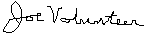 _______________________________________________
Field ID Number Surface Water: 03-999-01_________Bottom Water: 03-999-11-__

Sample ID #  (for lab use) | 3. Time | Sample container  (# / type) | Exact sampling location | Matrix | Total P  (unfiltered, preserved with H₂SO₄) | NO3 +NO2 & TKN  (unfiltered, unpreserved) | pH, Sp.Cond,  (unfiltered, unpreserved) | Chl.a  (filter preserved with MgCO₃) | Calcium  (unfiltered, preserved with HNO₃) | Color  (field filtered, unpreserved)
 | 2/29/03  1030 | 1 125 ml plastic w/H₂SO₄  1 125 ml plastic, filtered  2 125 ml plastic, unfiltered  1 125 ml plastic w/HNO₃  1 glass vial w/filter | Lake surface | Water | X | X | X | X | X | X
 |  | 1 125 ml plastic w/acid  1 125 ml plastic,  unfiltered | Lake  bottom | Water | X | X
 |  | Ziplock bags | See attached field sheet | plants
SAMPLING VOLUNTEERS- PROVIDE INFORMATION IN BOXES
1. Date, 2. Sampled By (Printed), 3. Time (Military Hours), 4. Sample Relinquished By (Signature)
Remarks: _________________________________________________________________________________
Sample bottles prepared by: ____ ____ Date: ___4/1/03___Time:_1000
4. Sample relinquished by: ____ _____ Date: ___6/32/03_ Time: 830 29900_______
Received @ UFI laboratory signature: ________________________Date: ___________Time: _______
b. Section 2: Sampled By: this box should be filled with the signature of the primary sampler. If more than one person conducts the sampling (such as one person conducting the Secchi disk transparency readings, a second collecting the water samples, and a third doing the transcriptions), a signature from any of these people will be adequate
c. Section 3: Time: this box should include both the data and time of sampling- see the example in Figure 5. Time should be recorded in military hours (8am = 800, 1230pm = 1230, 520pm = 1720, etc.). Make sure this time corresponds to the time recorded on the Sampling Record.
d. Section 4: Sample Relinquished By: this box should include the signature of the person dropping the box to the package delivery service (UPS, US Postal Service, etc.)- see Figure 5.

SAMPLE PACKING AND TRANSPORT

Step 1: Water Samples
a. Place the processed water sample bottles, chlorophyll a plastic vial, and two frozen ice packs into one of the mailing boxes.
b. If vegetation samples were collected as part of the Aquatic Vegetation Sampling project (optional- see below), place the bags with individual vegetation samples in the boxes on top of the sample bottles
c. If there is still excess room in the boxes, place newspaper or other filler in the empty spaces
d. Place the lid securely on top of the styrofoam box

Step 2: Paperwork
a. Place the Sampling Record, Field Observations Form, and Laboratory Record: Request for Analysis/Chain of Custory Form, and return addresss postage label on top of the styrofoam box
b. Place the Dissolved Oxygen Sampling Form, the Aquatic Vegetation Sampling Form, and any other information or correspondence to the NYSDEC or NYSDOH on top of the styrofoam box. If the sampling box is to be returned to someone other than the primary volunteer, or if the NYSDOH does not have the correct address for the volunteers or associations, please include a return address with the paperwork. The correct address should be written on a blank label provided in the package of materials sent to the lake association at the start of the sampling season

c. If pre-paid UPS or other private mail carrier forms are used for shipping and returning boxes, fill in the appropriate “send to” address information on the address labels provided in the sampling kit, and attach loosely (not affixed) to the top of the styrofoam box. This will allow lab personnel to easily get the box back to the primary sampling volunteer. If the US Postal Service is used, please provide any change of address information on a piece of paper and attach loosely to the top of the Styrofoam box.

Step 3: Sample Transport
a. Place the styrofoam box in the cardboard mailing crate
b. Close and seal the box with packing tape
c. Complete any return address information required on the pre-paid mailing label address to the laboratory
d. Place a pre-paid mailing label (UPS, US Postal Service, or other) on top of the box. For UPS shipping, additional instructions will be provided separately from this sampling protocol. If US Postal Service labels are used, there may be a frame (surrounding a secure plastic bag) in which the label may be placed. If not, the label has a sticky back that can be peeled away from the face of the label. In either case, the label should be placed on one of the flaps on top of the box, not on the tape covering the gap between the flaps
d. Transport the labeled box to the closest USPS or private carrier outlet, or the US Post Office for deliver to the laboratory

ADDITIONAL SAMPLING PROTOCOLS

A. TEMPERATURE/DISSOLVED OXYGEN PROFILES

1. BACKGROUND

Water temperature serves as a driving force for many important lake processes. The temperature controls the length of the growing season in lakes, which ultimately dictates the type and amount of biological activity. Many lakes are thermally stratified, forming distinct layers of differing temperature and density. These layers are referred to as the epilimnion (surface layer) and hypolimnion (bottom layer), separated by a metalimnion (a thin middle layer). The greatest changes in temperature occur at the thermocline in the metalimnion. Physical and chemical changes within these layers also influence the cycling of nutrients and other elements within the lake system. One such element affected by temperature is oxygen.
As temperatures increase, the amount of oxygen that can be dissolved in water decreases. Oxygen levels also are influenced by the time of day (due to oxygen production by photosynthetic processes during the daylight hours, and oxygen consumption by respiration at night), and by oxygen requirements by bacteria and other aquatic organisms. The bottom waters of many stratified lakes are susceptible to oxygen depletion, since atmospheric replenishment and photosynthetic production are decreased at greater water depths. Low oxygen concentrations can result in the loss of susceptible organisms, such as trout and other coldwater fish, and can accelerate the release of nutrients from bottom sediments.
Temperature and dissolved oxygen are typically measured as surface-to-bottom profiles, with measurements of both parameters collected at regular intervals, usually in one meter increments. Electronic temperature/dissolved oxygen meters provide the most accurate and easiest means for collecting these data. Unfortunately, the high cost associated with electronic meters precludes their use in most simple monitoring programs. As an alternative, dissolved oxygen test kits can be used with a thermometer and a grab-sample collector (such as the Kemmerer bottle) to construct these temperature/dissolved oxygen profiles. This is a more cost-effective, but less time-effective means for collecting these data (probably 30-60 minutes to construct a profile, vs. 10-20 minutes for a profile using an electronic meter). Sampling protocols for the use of electronic meters is provided here, but protocols are also available from the NYSDEC for sampling protocols for these less expensive but more time consuming methods.

2. SAMPLING DAYS AND TIMES

Since the temperature and dissolved oxygen profiles will most likely be used as a water quality assessment tool, they should be collected at the same time as water samples are collected. The dissolved oxygen concentrations of the surface waters will probably be maximized by choosing a sampling time during daylight hours, due to the photosynthetic activity near the lake surface. The time required to construct these profiles, however, may dictate the sampling time and date when the water samples and temperature/dissolved oxygen data will be collected.

3. SAMPLING LOCATION

As with sampling time, the sampling location for the temperature/dissolved oxygen profiles should be the same as for the water sample collection. In fact, one of the reasons why CSLAP water samples are collected at the deepest part of the lake is because this is the most appropriate location for constructing these profiles. Although temperature and dissolved oxygen data are useful information for any lake, these data are most useful in thermally stratified lakes. As such, this protocol is recommended for use in lakes (and at sampling sites) with a maximum depth of at least 8 meters.

4. NUMBER OF REQUIRED MEASUREMENTS

The most common sampling frequency in temperature and dissolved oxygen monitoring as part of a long-term water quality monitoring program is during each sampling session, with measurements recorded in one-meter intervals from the lake surface to the water-sediment interface. When electronic dissolved oxygen meters are available, such frequency sampling is easily achievable, and should constitute the “norm”. For lakes substantially deeper than approximately 25 meters, measurements may be collected in one-meter intervals to the depth of the thermocline, and then in 3-5 meter intervals to the bottom of the lake.

TEMP/D.O. SAMPLING EQUIPMENT CHECKLIST
Equipment to be brought into the boat

______ anchor and line (at least 2x as much line as depth of lake)
______ lake map
______ watch to record the time of day
______ pen or pencil
______ CSLAP Sampling Protocol
______ “Temperature and Dissolved Oxygen Profiles Sheet”
______ electronic dissolved oxygen meter
______ electronic meter with battery pack or alkaline batteries
______ probe with cable and winder
______ membrane replacement kit
______ one safety jacket per boat passenger (required by US Coast Guard)
______ first aid kit (optional)
DISSOLVED OXYGEN SAMPLING PROTOCOL:
USING AN ELECTRONIC DISSOLVED OXYGEN METER

NOTE- Each electronic dissolved oxygen meter is slightly different. These instructions were written for use with a standard YSI Model 58 or equivalent meter. Newer models may have automated calibration procedures or specific instructions for more precise air- or water-based calibrations. In addition, probes utilizing standard membranes require occasional membrane replacement and probe maintenance which are not discussed in this manual. Please consult the operating manual provided with the meter and probe for modifications from these instructions

Step 1: Zero and Pre-Calibrate the Meter
a. Unless there are data that suggest the lake is saline, make sure the salinity knob is switched to “0”
b. Turn function switch on meter to ZERO
c. Adjust the O₂ ZERO knob until the display reads “00.0”. If the leading decimal point is on, or there is no decimal point lit, or if there is no display, then the batteries have expired. If fresh batteries are available, replace the batteries one at a time (disconnect one, replace with a 9 Volt Alkaline battery, then disconnect the other and replace). If the meter requires a recharged battery or alkaline batteries are not available, return to the shoreline and consult the maintenance instructions provided with the electronic meter
d. Turn function switch to %, and let sit for 15 minutes. This may be done upon entering the boat to save time
e. Check the probe membrane for any bubbles. If bubbles are found, consult the probe instructions manual to replace the membrane

Step 2: Locate the Sampling Site and Anchor Boat
a. Refer to CSLAP SAMPLING PROTOCOL: ON-LAKE PROCEDURES, Step 2. for locating the sampling site
b. If these procedures are being performed after a water sample was collected from the deepest part of the lake, the site should already have been located, and the anchor already secured

Step 3: Calibration
a. Once the display has stabilized, adjust the O₂ CALIBRATE control to the proper calibration number (CALIB VALUE) by looking at the Altitude Calibration chart included in the instruction manual or found on the back of the electronic meter. The appropriate calibration value corresponds to the approximate altitude of the lake. If the altitude is not known, set the calibration value = 98
b. Once the stabilitzed display reads this number, tighten the wide knob in the indicated direction

Step 4: Read Air Temperature
Turn the selector switch to TEMP, allow the display to stabilize, and read and record the air temperature on the Temperature/Dissolved Oxygen Profiles Sheet (Figure 6)
FIGURE 6
TEMPERATURE/DISSOLVED OXYGEN PROFILES SHEET

LAKENAME __________________________________________
DATE __________________________________________
TIME __________________________________________
SOUNDING DEPTH (METERS) __________________________________________
AIR TEMPERATURE (°C) __________________________________________

Depth Temp D.O. | Depth Temp D.O.
(meters) (°C) (mg/l) | (meters) (°C) (mg/l)
|
surface | 21.0
1.0 | 22.0
2.0 | 23.0
3.0 | 24.0
4.0 | 25.0
5.0 | 26.0
6.0 | 27.0
7.0 | 28.0
8.0 | 29.0
9.0 | 30.0
10.0 |
11.0 |
12.0 |
13.0 |
14.0 |
15.0 |
16.0 |
17.0 |
18.0 |
19.0 |
20.0 |
Step 5: Turn On Stirrer and Take Water Temperature and Oxygen Readings
a. If the electronic meter has a stirrer, flick the switch to ON
b. Lower the probe into the water until just the probe is submersed
c. Keep the selector switch on TEMP, allow the display to stabilize (usually less than 60 seconds), and read and record the water temperature. This can be considered the water surface reading (depth = 0 meters)
d. Switch the selector to the desired dissolved oxygen sensitivity (either 0.01 mg/l or 0.1 mg/l), allow the display to stabilize (usually less than 60 seconds), and read and record the surface dissolved oxygen content (in mg/l)

Step 6: Determine if Surface Readings are Correct
a. Consult the back of the electronic meter or the meter instructions manual for a chart listing the solubility of oxygen in water as a function of temperature
b. Determine the oxygen solubility given the surface water temperature measured in Step 5
c. If the D.O. measurement from Step 5 is not more than 1-2 mg/l higher than the value reported on this chart (i.e. the measured value is lower, equal to, or less than 1-2 mg/l higher), then go to Step 7.
d. If the D.O. measurement from Step 5 is more than 1-2 mg/l higher than the value reported on this chart, check the membrane again for a bubble
e. If no bubble is found, return to Step 5 and perform the surface temperature and dissolved oxygen reading again.
f. If the D.O. measurement is still more than 1-2 mg/l greater than the chart value, consult the instruction manual to replace the membrane.

Step 7: Construct Temperature/Dissolve Oxygen Profile at Depth Intervals
a. Lower the probe down to the first meter mark (where the mark is flush with the water surface), and read dissolved oxygen (as either 0.01 mg/l or 0.1 mg/l) and TEMP, allowing each display to stabilize before recording
b. Continue lowering the probe and alternate reading oxygen and temperature measurements one meter at a time (one mark at a time). If at the previous depth, oxygen was read first and then temperature, at this depth read temperature first and then switch the selector and read oxygen. This reduces the number of times switching the selector, and should reduce the time for stabilization
c. Record all measurements on the Temperature/Dissolved Oxygen Profiles Sheet. Add any additional data points to this sheet as needed.
d. When the probe is one meter or so from the bottom (as determined by the Secchi disk measured line and the dissolved oxygen probe line), stop reading to prevent the probe from touching the lake floor

Step 8: Bring Oxygen Meter Back to the Boat
a. Turn the meter back to OFF and return to the boat
b. Make sure the cable is wrapped around either the winder or the brackets behind the meter; if a bracket is used, make sure that the first few inches of the cable (from the meter) always remain perpendicular to the meter housing (to prevent severing of the cable internal wiring, never rest meters with winder brackets with the display facing perpendicular to the ground)

Step 9: Complete Paperwork
a. Make sure all of the paperwork completed during the temperature/dissolved oxygen sampling session are completed, including the LakeName, Date, Time, Sounding Depth, and Air Temperature at the top of the sheets
b. Add the Temperature/Dissolved Oxygen Profiles Sheet to the paperwork from the water sampling session, the aquatic vegetation session, and any other sampling efforts. All paperwork should be placed on top of the styrofoam lid in the mailing package

ADDITIONAL SAMPLING PROTOCOLS

B. AQUATIC VEGETATION SAMPLING

1. BACKGROUND

Aquatic vegetation plays a critical role in lake ecosystems. Although the larger class of aquatic vegetation includes the microscopic plants includes free-floating algae (phytoplankton), algae attached to surfaces (periphyton), and larger branched alga (charaphytes), this discussion will be limited to larger rooted plants referred to as macrophytes. Macrophytes serve a crucial function in providing food, shelter, bottom stability, and nutrient transport to and from the sediment. However, macrophytes can also proliferate in the wrong places at the wrong times, frequently earning the title “weed”. Of particular concern to many lakefront residents and recreational users are the exotic, or non-native macrophytes, which can frequently dominate a native aquatic plant community and crowd out more beneficial species. Macrophytes can be found throughout the littoral zone, the near-shore areas in which sufficient light reaches the lake bottom to promote phytosynthesis. However, plant growth in any particular part of the lake is a function of available light, nutrition and space, bottom substrate, wave action, and other factors.
Whether the lake managers role is to better understand the lake ecosystem or better manage the aquatic plant community, knowledge of the macrophyte species distribution is paramount to the management process. There are many procedures available for assessing and monitoring aquatic vegetation. Some of these techniques have been described in “Aquatic Vegetation Monitoring and Assessment Protocol Manual”, developed by the NYS Fresh Water Institute. Many plant quantification techniques require SCUBA divers, precise on-site plant identifications, rigid sampling controls, and biomass measurements, most of which are beyond the scope (financial and technical) of CSLAP and other volunteer monitoring efforts. This protocol describes the procedures for a “semi-quantitative” plant monitoring program, in which volunteers collect plant specimen from known locations, providing field information and qualitative abundance estimates for a semi-quantative assessment of the macrophyte communities within critical areas of the lake. While these techniques will help to provide better information for lake managers interested in optimizing their understanding and management of the lake, they are inadequate substitutes for professional plant surveys. Lake associations planning to devote significant time and expenditures toward a plant management program are advised to pursue more extensive plant surveying activities.

2. FOCUS OF SAMPLING EFFORTS

Although too much of any aquatic plant can be considered a problem, most invasive aquatic plants (those that create ecological, recreational, or aesthetic problems) are exotic plants- that is, those plants that are not native to a particular lake or geographic area. In New York State, there are four primary submergent exotic plants- Eurasian watermilfoil (Myriophyllum spicatum), water chestnut (Trapa natans), curly-leafed pondweed (Potamogeton crispus) and fanwort (Cabomba caroliniana). Tracking, management, or eradication of these plants necessitates an early detection of the introduction of these plants to a lake. To that end, the NYSDEC developed a pamphlet titled Common Nuisance Aquatic Plants in New York State, which provides information, including known distribution maps, and line drawings and photographs of these four plants. CSLAP sampling volunteers involved in the collection of aquatic plants should also be on the lookout for these exotic plants, and for most CSLAP lakes, these plants will provide the focus for the aquatic plant monitoring efforts conducted through this program.

3. SAMPLING DAYS AND TIMES

Aquatic plant (macrophyte) communities do not experience significant daily fluctuations; as such, the aquatic plant sampling techniques described below can be conducted after water sampling sessions, at a time convenient to the volunteer. Given the time required to conduct these surveys, however, the volunteer is advised to keep the (previously-) collected water samples cool and shaded during the plant sampling sessions.
Due to the seasonal nature of macrophyte growing seasons, plant sampling need not be conducted any more frequently than every few months, say in early June (corresponding to the start of the CSLAP sampling season), mid-August, and in early October (the end of the CSLAP sampling season). Each sampled site, described below, should be visited at about the same frequency, to compare seasonal changes between sites. More frequent sampling could be conducted to assess on-going plant management techniques, but generally would provide little additional information for baseline assessments.

4. SAMPLING LOCATION

Ideally, sufficient sampling locations are chosen to construct a map of plant coverage throughout the littoral zone. However, time constraints may prevent the volunteer from choosing a multitude of sampling sites. Each CSLAP sampling location consists of three sites along a line perpendicular to the lakeshore (a transect): the deepest of these sites is found at a depth equivalent to the Secchi disk transparency, and the other two sites are spaced equidistant from the deep site to the shore. This deepest site will be close to the maximum depth of the littoral zone. If only a few sampling locations can be chosen, the areas in which sediment and nutrients are concentrated, such as the inlet and outlet, boat launch sites, marinas, or other shallow areas may serve as ideal monitoring locations. If the volunteer is interested in species identification within a particular plant bed (i.e. a particular site), the sampling transect can be placed through this site.

VEGETATION SAMPLING EQUIPMENT CHECKLIST
Equipment to be brought into the boat
(in addition to the standard lake sampling equipment listed on p. 9)

______ "CSLAP Aquatic Vegetation Survey Form(s)"
______ weighted sampling rake (with 10-20ft line attached to handle)
______ Secchi disk and measured line (for sounding depth)
______ sealable plastic bags (“baggies”) for plant specimens
______ tape or labels to mark plastic bags
______ permanent ink pen to write on the bag labels
______ plant identification keys (if available)

5. AQUATIC VEGETATION SAMPLING PROTOCOL

Step 1: Locate the sampling site
a. From the boat launching site or area of excessive weed growth, travel in a line perpendicular from the shore to the designated vegetation survey depth. This depth should be within ½ meter of the maximum Secchi disk transparency recorded during the present sampling season
b. Confirm this depth with the Secchi disk, and lower the anchor
c. Record this depth and a description of the sampling site, including location and an approximate distance from the shoreline, on the Aquatic Vegetation Sampling Form (Figure 7)

Step 2: Collect the submergent plant sample
a. Facing the shoreline, pitch the rake out the back (the side opposite from the shore) of the boat, several feet away, making sure the tines (teeth) of the rake are pointed down toward the water
b. Allow the rake to rest on the floor of the lake
c. Pulling inward on the rake or rakeline, drag the rake for a few feet along the bottom
d. Bring the rake back into the boat.
e. Remove all vegetation trapped on the tines, and place into separate piles according to plant types (each type in a different pile). If you are not confident that any two types (species) are different, then place each type in a separate pile (when in doubt, assume they are different)

FIGURE 7: CSLAP AQUATIC VEGETATION SURVEY FORM

Lake Name: _________________Date:_________Sampling Location: ___________________________

SITE 1
Depth (meters): _____________ Distance to Shore (feet): __________________
SUBMERGENT EMERGENT
Plant # % Plant Abundance Plant Letter Abundance
1 (scarce, moderate, abundant)
2 A
3 B
4 C
5 D
6 E
7 F
TOTAL 100 G
OVERALL SUBMERG. ABUNDANCE (circle one): OVERALL EMERG. ABUNDANCE (circle one):
(none, scarce, moderate, abundant, very abundant) (none, scarce, moderate, abundant, very abundant)
Dominant Bottom Condition (circle one: mud, sand, rock, debris, unknown, other _______________________)

SITE 2
Depth (meters): _____________ Distance to Shore (feet): __________________
SUBMERGENT EMERGENT
Plant # % Plant Abundance Plant Letter Abundance
1 (scarce, moderate, abundant)
2 A
3 B
4 C
5 D
6 E
7 F
TOTAL 100 G
OVERALL SUBMERG. ABUNDANCE (circle one): OVERALL EMERG. ABUNDANCE (circle one):
(none, scarce, moderate, abundant, very abundant) (none, scarce, moderate, abundant, very abundant)
Dominant Bottom Condition (circle one: mud, sand, rock, debris, unknown, other _______________________)

SITE 3
Depth (meters): _____________ Distance to Shore (feet): __________________
SUBMERGENT EMERGENT
Plant # % Plant Abundance Plant Letter Abundance
1 (scarce, moderate, abundant)
2 A
3 B
4 C
5 D
6 E
7 F
TOTAL 100 G
OVERALL SUBMERG. ABUNDANCE (circle one): OVERALL EMERG. ABUNDANCE (circle one):
(none, scarce, moderate, abundant, very abundant) (none, scarce, moderate, abundant, very abundant)
Dominant Bottom Condition (circle one: mud, sand, rock, debris, unknown, other _______________________)

f. Once all the vegetation has been removed, repeat Step 2a through Step 2e two more times, for a total of three collections at this depth. Any species found in these subsequent collections should be placed in the same piles as the first collection (there should only be one pile for any given plant type)

Step 3: "Processing" the submergent plant samples
a. After the three collections have been separated, take one or two plants from each pile, shake off all excess water, place the plant(s) into a plastic (ziplock) bag, and zip the bag shut. Try to select a plant which is most completely developed, possessing leaves, blossoms, fruits, nuts, and roots. Try to remove all excess air from the bag
b. Place a labeled piece of masking tape on each bag; label each plant type (bag) with a number (type #1, type #5, etc.), one number for each bag. Also write the lake name and date on each bag
c. Estimate the percentage of each plant type from the three collections at this site. For example, 50% of type #1, 25 % of type #2, 15% of type #3, etc., for a total of 100% . Record the species number and the estimate of percent abundance on the survey form (Figure 7), under the section marked SUBMERGENT
d. Estimate the amount of submergent (underwater) vegetation pulled by the rake as either "none", "scarce", "moderate", "abundant", or “very abundant” and record on the form under OVERALL SUBMERGENT PLANT ABUNDANCE (Figure 7). As a general rule of thumb, “scarce” refers to plants found on the rake tines in only one or two of the throws or only a few scattered plants on the tines in all throws; “moderate” refers to incomplete tine coverage in the three throws; “abundant” refers to complete tine coverage for all three throws, and “very abundant” refers to dense tine coverage on all three throws
e. Place all remaining plants (piles) somewhere inside the boat for later disposal.
f. If it is possible to see the bottom, record the soil conditions on the lake floor (mud, sand, rock, debris, etc.). This can also be estimated from material deposited on the anchor (seen when the anchor is pulled after Step 4)

Step 4: Assessing the emergent plant populations
a. Look for any plants emerging from the water surface (that were not pulled by the rake) at the sampling site. Pull one of each of these emergent plants, including any flowers or stems (if possible), shake off excess water, and place in a labeled bag (label this bag with the lake name, date, and a letter, starting with "A")
b. Record the plant type (letter) and the frequency with which this type occurs at this site ("none", "scarce", "moderate", "abundant", or “very abundant”, see Step 4d below to define these terms) under the section marked EMERGENT (Figure 7)
c. If any plant is too large to be pulled, give a general description of the plant (noting any distinguishing or unusual characteristics) and estimate the distance the plant rises above the water surface. Also note any algae sticking to rocks, logs, or other plants in or above the water at this site. Record this and any other plants seen but not collected at this site under the section marked OTHER (Figure 7)
d. Estimate the amount of emergent (above water) vegetation surrounding the boat at this sampling site as either "none", "scarce", "moderate", "abundant", or “very abundant” and record on the form under OVERALL EMERGENT PLANT ABUNDANCE (Figure 7). As a general rule of thumb, “scarce” refers to scattered individual plants found on the lake surface; “moderate” refers to groups of plants covering part of the lake surface; “abundant” refers to complete lake coverage, and “very abundant” refers to dense (thick or multi-layer) plant coverage at this site. The emergent plant abundance should be estimated even if emergent plants are not collected and sent for identification

Step 5: Collect plants at additional depths and sites
a. Moving toward shore (in a straight line perpendicular to the shoreline), repeat Step 1b through Step 4c two more times (sites #2 and #3). Space these sampling sites an equal distance apart. For example, if the original (first) vegetation sampling site is about 60 feet from the shoreline, the other two sampling sites should be approximately 40 feet and 20 feet, respectively, from the shoreline
b. Any plants previously labeled should not be relabeled at later sites. For example, if the plant labeled type #1 at the first site is found again at the second site (depth). it should still be recorded as type #1. Additional specimen should not be placed in a bag
c. Complete Step 1a through Step 4c for any other locations throughout the lake, using the areas marked Sites 2 and 3 on the vegetation sampling form (Figure 7). During each vegetation sampling session, at least the primary sampling site should be surveyed
d. Upon returning to shore, dispose all dried plants in the garbage, not back in the lake

Step 6: Package and transport plants to the lab
a. Identify the collected plants, to the best of your ability, if an identification key is provided. Record this information on the back of the aquatic vegetation survey form, using the same plant type numbers and letters assigned earlier
b. Send all labeled vegetation bags and the vegetation survey form(s) in the styrofoam cooler with ice packs to the laboratory, if possible with any collected water samples. If there is not sufficient room in the cooler, and there are no water samples being sent, remove one ice pack and send along, or send with one in an empty cooler (without water samples)

CONVERSIONS

1. Distance- Meters to Feet 2. Temperature- °C to °F

Meters Feet °C °F

0.3 1.0 0.0 32.0
0.5 1.6 5.0 41.0
1.0 3.3 10.0 50.0
1.5 4.9 11.0 51.8
2.0 6.6 12.0 53.6
2.5 8.2 13.0 55.4
3.0 9.8 14.0 57.2
3.5 11.5 15.0 59.0
4.0 13.1 16.0 60.8
4.5 14.8 17.0 62.6
5.0 16.4 18.0 64.4
5.5 18.0 19.0 66.2
6.0 19.7 20.0 68.0
6.5 21.3 21.0 69.8
7.0 23.0 22.0 71.6
7.5 24.6 23.0 73.4
8.0 26.2 24.0 75.2
8.5 27.9 25.0 77.0
9.0 29.5 26.0 78.8
9.5 31.2 27.0 80.6
10.0 32.8 28.0 82.4
15.0 49.2 29.0 84.2
20.0 65.6 30.0 86.0
25.0 82.0 35.0 95.0
30.0 98.4 40.0 104.0
50.0 164.0 100.0 212.0
Appendix A- Common Nuisance Aquatic Plants in New York State

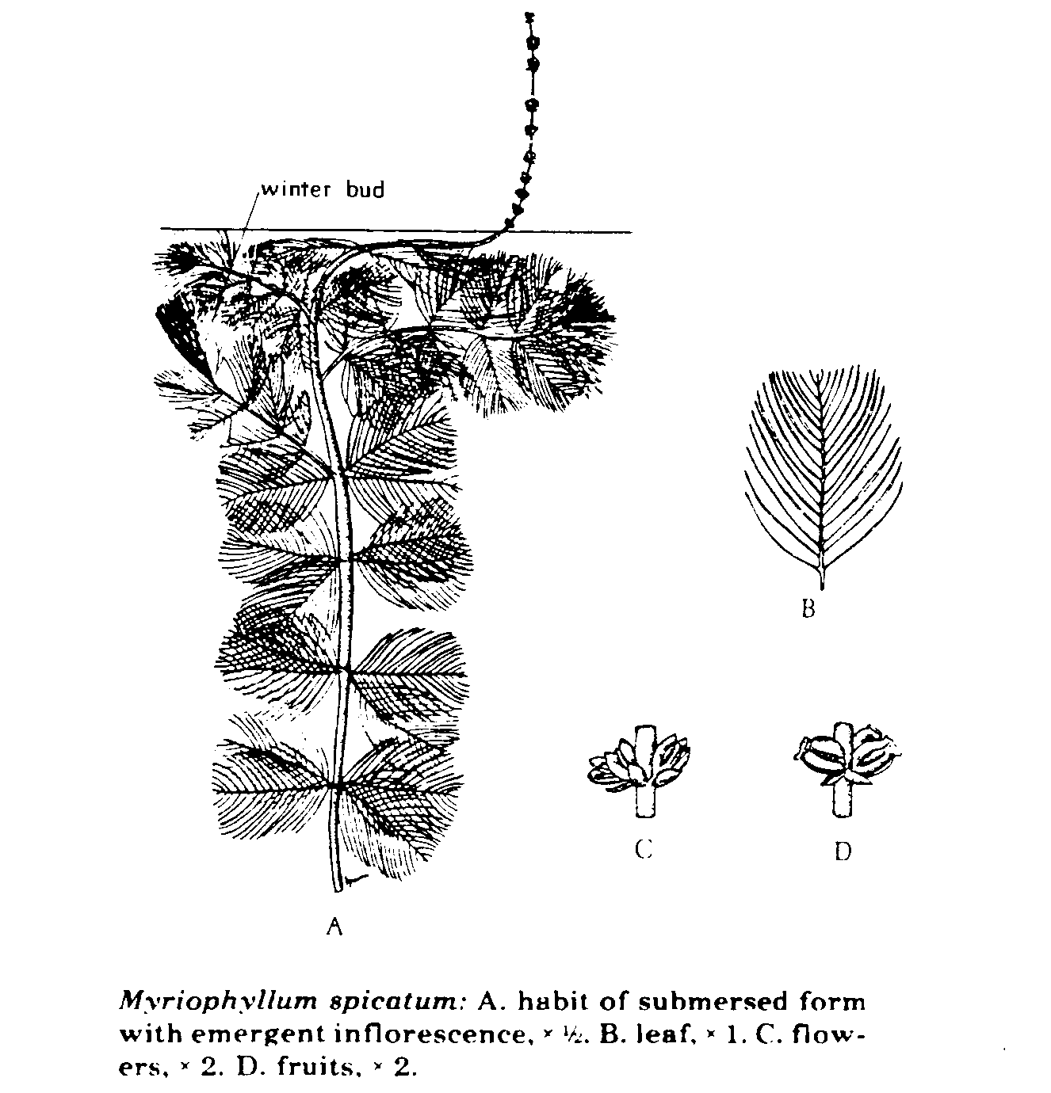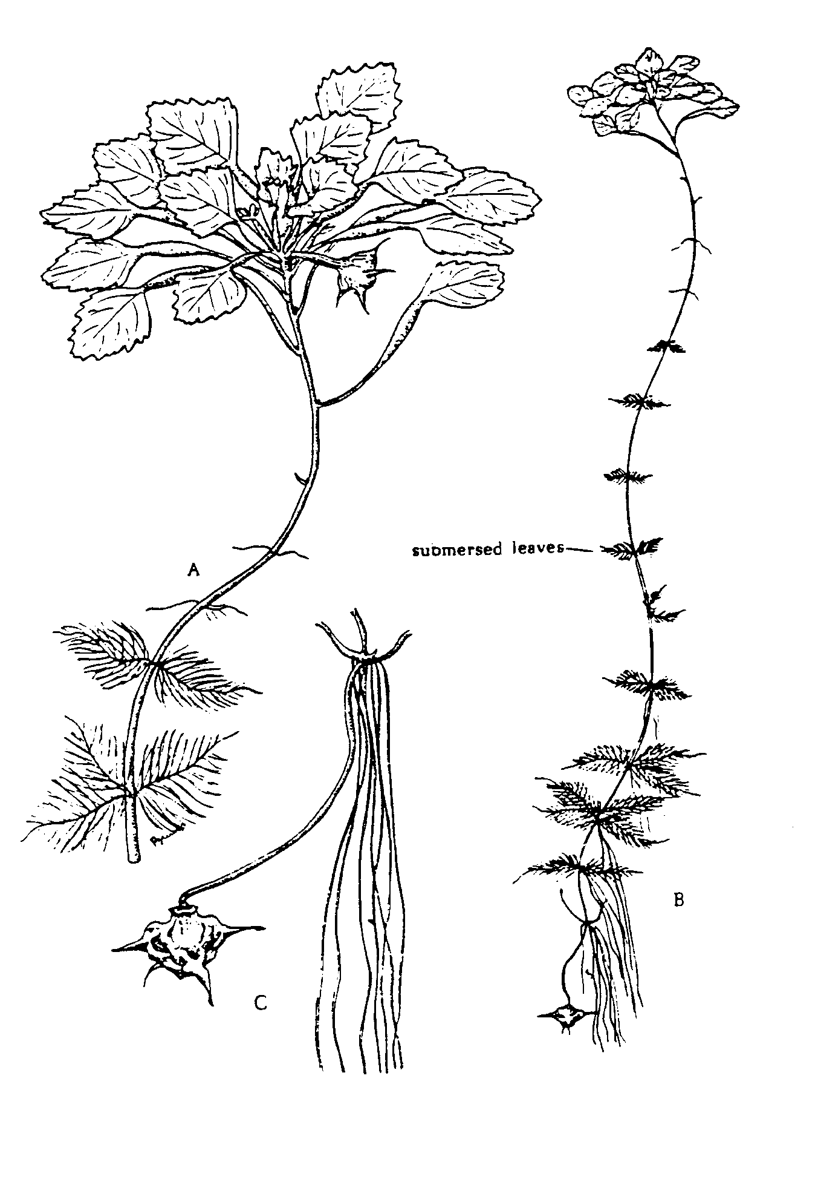

Eurasian watermilfoil (Myriophyllum spicatum) Water chestnut (Trapa natans)

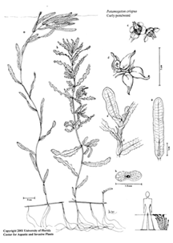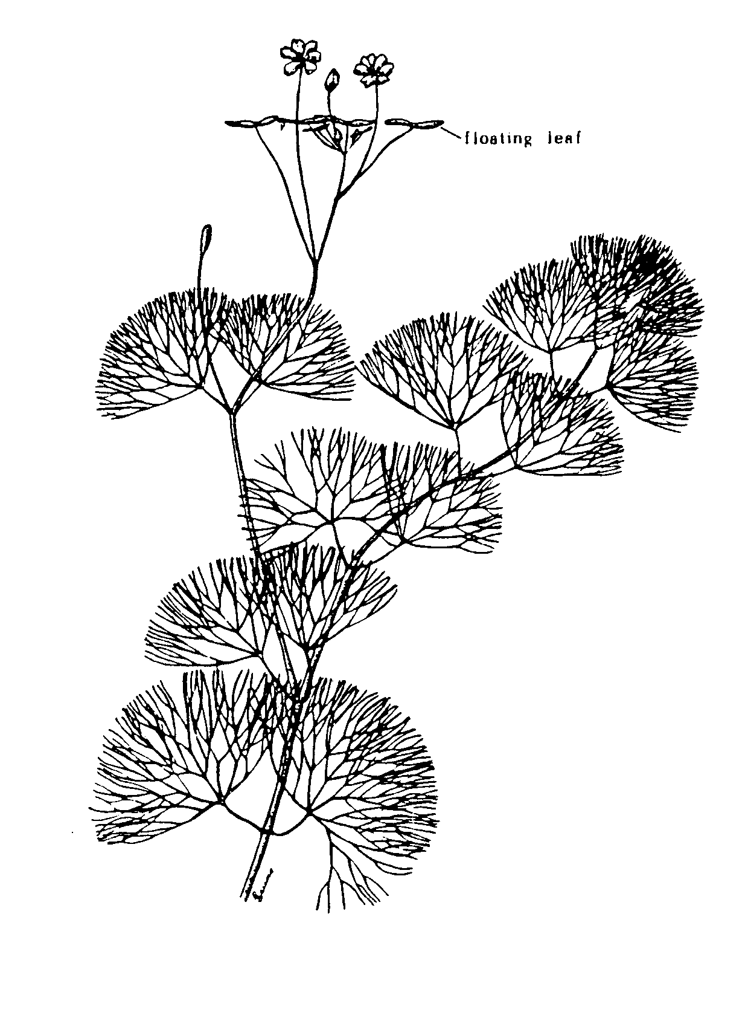
Curly-leafed pondweed (Potamogeton crispus) Fanwort (Cabomba caroliniana)

